Primary key:
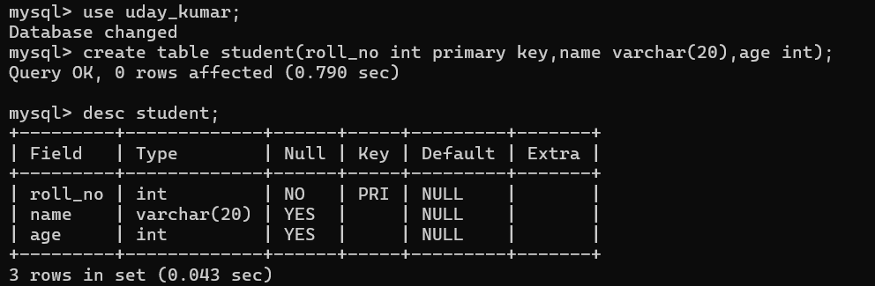
Foreign key:
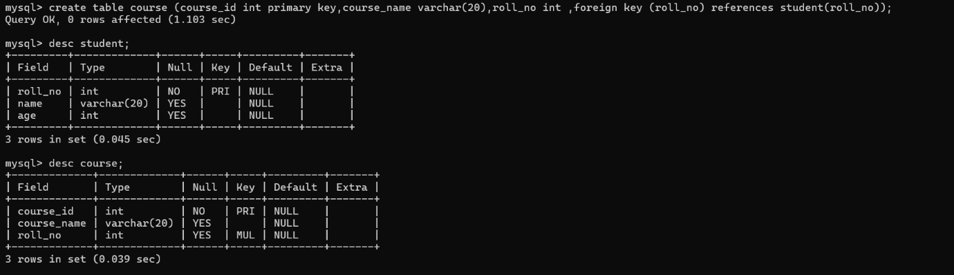
Unique key:
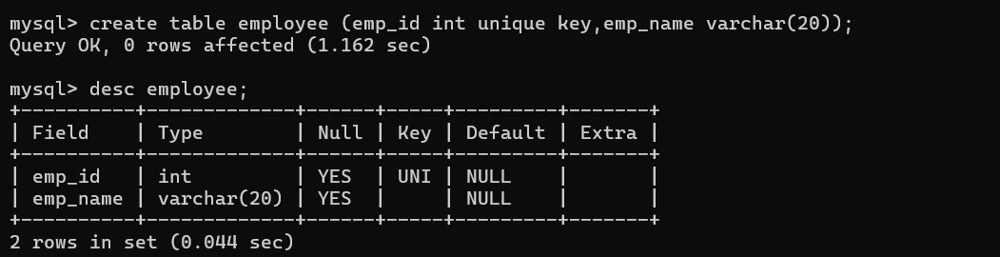
Check:
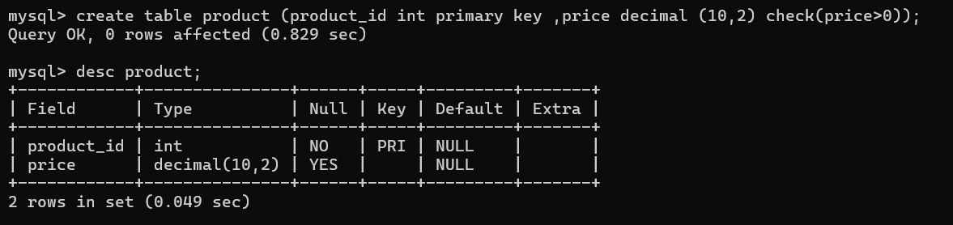

Default:
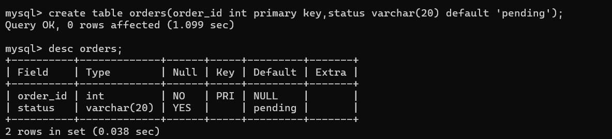
Null:
